GV Marketplace Application

Alex Fountain, Jarred Parr, Ron Rounsifer, Sean Greene

CIS 350-01 Fall 2017

Description:

In this project we plan to create an IOS, and Desktop application. This application will take the place of the multiple Facebook pages that have been created for students to sell books, get a tutor, or find someone to lease from. The application will be called GV Marketplace. The desktop application will be written in java and fxml. The fxml will be created through JavaFX. The IOS application will be created through Javascript. We will also be building our own API for the application. Most of the testing will come from the second half of the project as the user interface design is the key focus for the first half of the project.

Release 1 Supports:

The desktop application user interface is complete.

The IOS/Android application is fully functioning. The user can view posts, create posts, and create a profile.

Outlook:

In release two we will add full functionality to the desktop application. We will also add messaging capabilities to the IOS/Android application. Some other small features will also be added like location services.

Repositories:

Mobile:

<https://github.com/jparr721/GvMarketplace>

Desktop:

<https://github.com/jparr721/GvMarketplace-desktop>

Git Log:

│commit 3328e8b65aae2fac323720bb7fb71f692d9aaaff

│Author: Jarred Parr <jparr721@gmail.com>

(env) ✝ Python Projects/plur/djank │commit dbb1dfbce85e08b02d454e500612d32ecbf6e986

│Author: Ronald Rounsifer <ronrounsifer@me.com>

Date: Mon Oct 16 12:18:18 2017 -0400

│

│ Added more comments to the following: inbox.js, login.js, app.js, ./actions/inde

│x.js, and ./reducers/index.js

│

│commit e89d85fb43d48f6411f0639b7c0cf4f493901689

│Merge: 92c0309 5094b74

│Author: Ronald Rounsifer <ronrounsifer@me.com>

│Date: Mon Oct 16 08:44:32 2017 -0400

│

Added more comments to the four pages of the application.

│

│commit 92c030942f439d7535b2c37b4e65f3fb26b6c798

│Author: Ronald Rounsifer <ronrounsifer@me.com>

│Date: Mon Oct 16 08:41:56 2017 -0400

│

More comments added to the login, browse, inbox, and settings page of the applic

│ation.

│

│commit 5094b746edbbdb8565b956ab3560f32bcbeec920

│Author: greenese <31932398+greenese@users.noreply.github.com>

│Date: Mon Oct 16 01:36:56 2017 -0400

│

│ Added a controller class for Marketplace.fxml and some testing for the controllers

│commit ae9c5dbe3d949c51408d3e6c7e46dbb854ad0ef2

│Author: Ronald Rounsifer <ronrounsifer@me.com>

│Date: Mon Oct 16 00:25:52 2017 -0400

│

│ More comments added

│

│commit f439e4df16682c10794125465b267ef2a2c6374e

│Author: Ronald Rounsifer <ronrounsifer@me.com>

│Date: Sun Oct 15 21:44:21 2017 -0400

│

│ Started comments for classes/functions

│

│commit 7cde913b2bd0d19e97191a1cbc3eea95f4076303

│Author: Jarred Parr <jparr721@gmail.com>

│Date: Sun Oct 15 19:54:48 2017 -0400

│

│ So many comments

│

│commit 14e0bfc24899c62da9493aa1d609d119f609522b

│Author: Ronald Rounsifer <ronrounsifer@me.com>

│Date: Sun Oct 15 10:20:46 2017 -0400

│

│ Messed with styling on settings page mostly

│

│commit 9469162d8ff0b988069b31662a82e657c23fafd5

│Author: Ronald Rounsifer <ronrounsifer@me.com>

│Date: Sun Oct 15 09:54:31 2017 -0400

│

│ Updated browse page

│

│commit 0b4e769872b4d2065c3ecb59679b00dfc971cd3f

│Author: Ronald Rounsifer <ronrounsifer@me.com>

│Date: Sun Oct 15 09:41:22 2017 -0400

│

│ Updating UI for pages

│

│commit ee2e0817457ad2a1f74b438c19649f32a9985c93

│Author: Jarred Parr <jparr721@gmail.com>

│Date: Sat Oct 14 15:04:12 2017 -0400

│

│ Create .gitignore │

│commit 1813e6a7675d5bb56a036ef05970216057224ea8

│Author: Jarred Parr <jparr721@gmail.com>

│Date: Sat Oct 14 15:02:59 2017 -0400

│

│ Update .gitignore

│

│commit 0455b1644e7500f4e7dd91f7a4f255e106691ff5

│Merge: 3eaf45e 64fd199

│Author: Jarred Parr <jparr721@gmail.com>

│Date: Sat Oct 14 14:19:35 2017 -0400

│

│ Merge pull request #13 from jparr721/small_changes

│

│ Added buttons to settings / Changed layout for settings

│

│commit 64fd1993760a38b01fbb22d5827e1d25ee52085e

│Merge: 7aef531 3eaf45e

commit 3d660fcb2f015b7c17eb65f1e2390e45ec6bc03b

Author: Alex <fountaia@mail.gvsu.edu>

Date: Mon Sep 25 12:53:55 2017 -0400

Started developing desktop application.

commit 7dcd3ba9fce732f203934ab54cc30235e0889d6d

Author: Alex <fountaia@mail.gvsu.edu>

Date: Mon Sep 25 12:47:33 2017 -0400

Started developing desktop application.

commit 4b8b207d4c7754e7cebdd656940d998f3a516575

Author: Jarred Parr [jparr721@gmail.com](mailto:jparr721@gmail.com)

Date: Tue Sep 19 20:39:08 2017 -0400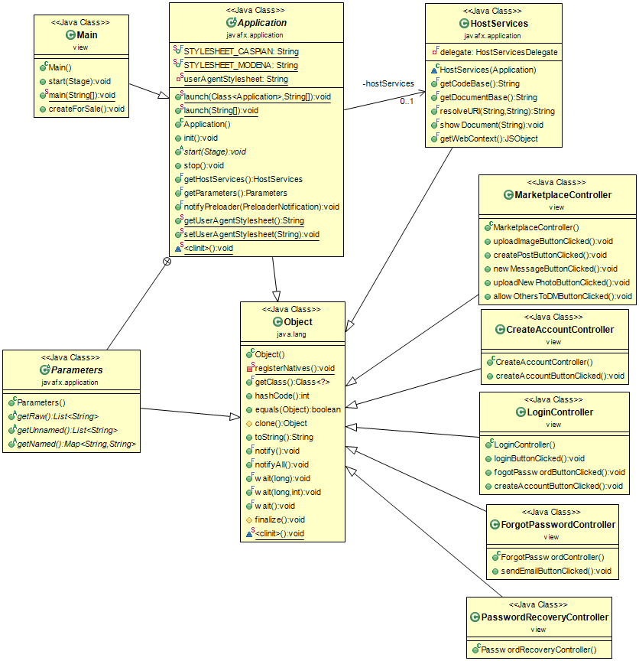

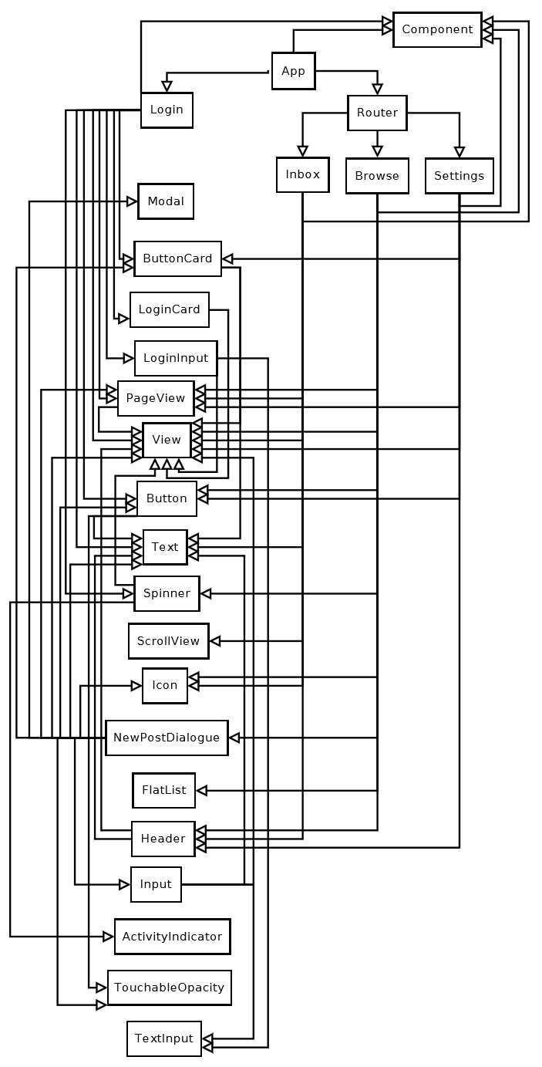

React Native Tests

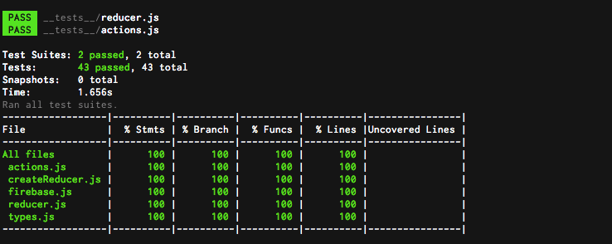

Desktop Testing:

Code Coverage

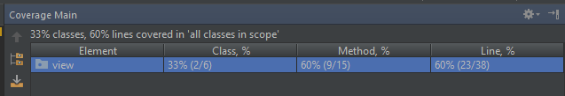

Find Bugs

Starting FindBugs analysis on file(s) from: GvMarketplace-desktop

Resolved auxiliary classpath (2 entries):

 C:\Users\Sean\git\GvMarketplace-desktop\bin

 C:\Program Files\Java\jre1.8.0_144\lib\rt.jar

Archives to analyze: 3

Start pass: 0 on 19 classes

Start pass: 1 on 6 classes

Finished, found: 0 bugs

Footprint: cpuTime=1515625000, clockTime=360, peakMemory=483959688

Total time:

PROFILE REPORT

   msecs    #calls usecs/call Class

      72       364       199 ClassInfoAnalysisEngine

      44       366       122 ClassDataAnalysisEngine

      19        19      1015 FieldItemSummary

      15        80       198 JumpInfoFactory

      13        19       735 FindNoSideEffectMethods

Total calls:

PROFILE REPORT

   msecs    #calls usecs/call Class

       1       753         1 DetectorToDetector2Adapter

      44       366       122 ClassDataAnalysisEngine

      72       364       199 ClassInfoAnalysisEngine

       0       332         2 ClassReaderAnalysisEngine

       9       327        30 TopologicalSort

       0       259         2 NonReportingDetectorToDetector2Adapter

      15        80       198 JumpInfoFactory

       4        42       100 JavaClassAnalysisEngine

       0        26        14 TypeQualifierNullnessAnnotationDatabase

       0        25         7 ClassContextClassAnalysisEngine

       3        19       184 BuildObligationPolicyDatabase

       4        19       244 BuildStringPassthruGraph

       4        19       239 CFGFactory

       4        19       216 CalledMethods

       0        19        30 CheckCallSitesAndReturnInstructions

       1        19        52 ConstantDataflowFactory

       0        19        27 DepthFirstSearchFactory

       2        19       122 EqualsOperandShouldHaveClassCompatibleWithThis

       0        19         1 ExceptionSetFactoryFactory

       3        19       169 ExplicitSerialization

      19        19      1015 FieldItemSummary

       0        19        10 FindBugsSummaryStats

      13        19       735 FindNoSideEffectMethods

       5        19       272 FunctionsThatMightBeMistakenForProcedures

       4        19       252 IsNullValueDataflowFactory

       0        19        33 LiveLocalStoreDataflowFactory

       0        19        11 LoadedFieldSetFactory

       1        19        77 MethodGenFactory

       0        19        19 Methods

       0        19        22 NoteAnnotationRetention

       0        19        22 NoteCheckReturnValueAnnotations

       5        19       268 NoteDirectlyRelevantTypeQualifiers

       0        19        31 NoteJCIPAnnotation

       0        19        39 NoteSuppressedWarnings

       3        19       188 NullDerefAndRedundantComparisonFinder

       3        19       191 OverridingEqualsNotSymmetrical

       2        19       122 ReflectiveClasses

       0        19        24 ReverseDepthFirstSearchFactory

       3        19       169 TypeDataflowFactory

       3        19       180 UnconditionalValueDerefDataflowFactory

       3        19       177 ValueNumberDataflowFactory

       0        19        12 ValueRangeAnalysisFactory

       1        18        97 SpecialTypeAnalysis

       0        13         4 LockCheckerFactory

       0        12        63 MethodFactory

       0        10        60 StreamResourceTracker

       0         6         5 AppendingToAnObjectOutputStream

       0         6        21 AssertionMethodsFactory

       0         6         4 AtomicityProblem

       0         6         6 BadResultSetAccess

       0         6        47 BadSyntaxForRegularExpression

       0         6        21 BadUseOfReturnValue

       0         6        20 BadlyOverriddenAdapter

       0         6        14 BooleanReturnNull

       0         6        20 CheckImmutableAnnotation

       0         6       122 CheckRelaxingNullnessAnnotation

       0         6         3 CheckTypeQualifiers

       0         6        25 CloneIdiom

       0         6         8 ComparatorIdiom

       0         6         1 ConfusedInheritance

       0         6         1 ConfusionBetweenInheritedAndOuterMethod

       0         6        48 ConstantPoolGenFactory

       0         6        48 CrossSiteScripting

       0         6       104 DefaultEncodingDetector

       0         6        43 DoInsideDoPrivileged

       0         6         7 DontCatchIllegalMonitorStateException

       0         6         7 DontIgnoreResultOfPutIfAbsent

       0         6        10 DontUseEnum

       0         6         7 DroppedException

       0         6        57 DumbMethodInvocations

       0         6       146 DumbMethods

       0         6        25 DuplicateBranches

       0         6         6 FinalizerNullsFields

       0         6        43 FindBadCast2

       0         6        50 FindBadForLoop

       0         6         7 FindComparatorProblems

       0         6       113 FindDeadLocalStores

       0         6        55 FindDoubleCheck

       0         6        21 FindEmptySynchronizedBlock

       0         6        42 FindFieldSelfAssignment

       0         6        18 FindFinalizeInvocations

       0         6        44 FindFloatEquality

       0         6        87 FindHEmismatch

       0         6       115 FindInconsistentSync2

       0         6        25 FindJSR166LockMonitorenter

       0         6        18 FindLocalSelfAssignment2

       0         6        23 FindMaskedFields

       0         6         8 FindMismatchedWaitOrNotify

       0         6        18 FindNakedNotify

       0         6        44 FindNonShortCircuit

       0         6       152 FindNullDeref

       0         6        35 FindNullDerefsInvolvingNonShortCircuitEvaluation

       1         6       187 FindOpenStream

       0         6        92 FindPuzzlers

       0         6       123 FindRefComparison

       0         6        51 FindReturnRef

       0         6         6 FindRoughConstants

       0         6        25 FindRunInvocations

       0         6        59 FindSelfComparison

       0         6        26 FindSelfComparison2

       0         6         6 FindSleepWithLockHeld

       0         6        17 FindSpinLoop

       0         6        15 FindSqlInjection

       0         6        15 FindTwoLockWait

       0         6        46 FindUncalledPrivateMethods

       0         6        12 FindUnconditionalWait

       0         6        15 FindUninitializedGet

       0         6        59 FindUnrelatedTypesInGenericContainer

       0         6         5 FindUnreleasedLock

       0         6        57 FindUnsatisfiedObligation

       0         6        17 FindUnsyncGet

       0         6       139 FindUseOfNonSerializableValue

       0         6        20 FindUselessControlFlow

       0         6        59 FindUselessObjects

       0         6        52 FormatStringChecker

       0         6        12 HugeSharedStringConstants

       0         6        17 IDivResultCastToDouble

       0         6        63 IncompatMask

       0         6        12 InconsistentAnnotations

       0         6        47 InfiniteLoop

       0         6        55 InfiniteRecursiveLoop

       0         6        38 InheritanceUnsafeGetResource

       0         6        16 InitializationChain

       0         6        24 InitializeNonnullFieldsInConstructor

       0         6        23 InstantiateStaticClass

       0         6        45 IntCast2LongAsInstant

       0         6         3 InvalidJUnitTest

       0         6         5 IteratorIdioms

       0         6         8 LazyInit

       0         6        74 LoadOfKnownNullValue

       0         6        10 LostLoggerDueToWeakReference

       0         6        85 MethodReturnCheck

       0         6         6 MultithreadedInstanceAccess

       0         6         1 MutableEnum

       0         6        14 MutableLock

       0         6        29 MutableStaticFields

       0         6        85 Naming

       0         6        18 NoteNonnullReturnValues

       0         6        28 NoteUnconditionalParamDerefs

       0         6        12 NumberConstructor

       0         6        13 OptionalReturnNull

       0         6         7 PreferZeroLengthArrays

       0         6        13 QuestionableBooleanAssignment

       0         6        49 ReadOfInstanceFieldInMethodInvokedByConstructorInSuperclass

       0         6        22 ReadReturnShouldBeChecked

       0         6        15 RedundantConditions

       0         6         1 RedundantInterfaces

       0         6        76 RepeatedConditionals

       0         6        75 RuntimeExceptionCapture

       0         6        87 SerializableIdiom

       0         6        10 StartInConstructor

       0         6        36 StaticCalendarDetector

       0         6        20 StringConcatenation

       0         6        16 SuperfluousInstanceOf

       0         6         3 SuspiciousThreadInterrupted

       0         6        84 SwitchFallthrough

       0         6        51 SynchronizationOnSharedBuiltinConstant

       0         6        35 SynchronizeAndNullCheckField

       0         6        40 SynchronizeOnClassLiteralNotGetClass

       0         6        37 SynchronizingOnContentsOfFieldToProtectField

       0         6        36 URLProblems

       0         6        13 UncallableMethodOfAnonymousClass

       0         6         4 UnnecessaryMath

       1         6       192 UnreadFields

       0         6        14 VarArgsProblems

       0         6        17 VolatileUsage

       0         6        16 WaitInLoop

       0         6         9 WrongMapIterator

       0         6        27 XMLFactoryBypass

Time per call:

PROFILE REPORT

   msecs    #calls usecs/call Class

Total bugs            :                    0

Peak memory (MB)      :                  461

Total classes         :                  366

Total time (msec)     :                  376

Class read time (msec):                   44

Class read time (%)   :                   12

Total bytes read      :              1381425

Application bytes     :                 4545

Application bytes (%) :                    0

Avg. bytes per class  :                 3774

Analysis class/sec    :                  973

Read     bytes/sec    :             31396023

            MB/sec    :                 29.9 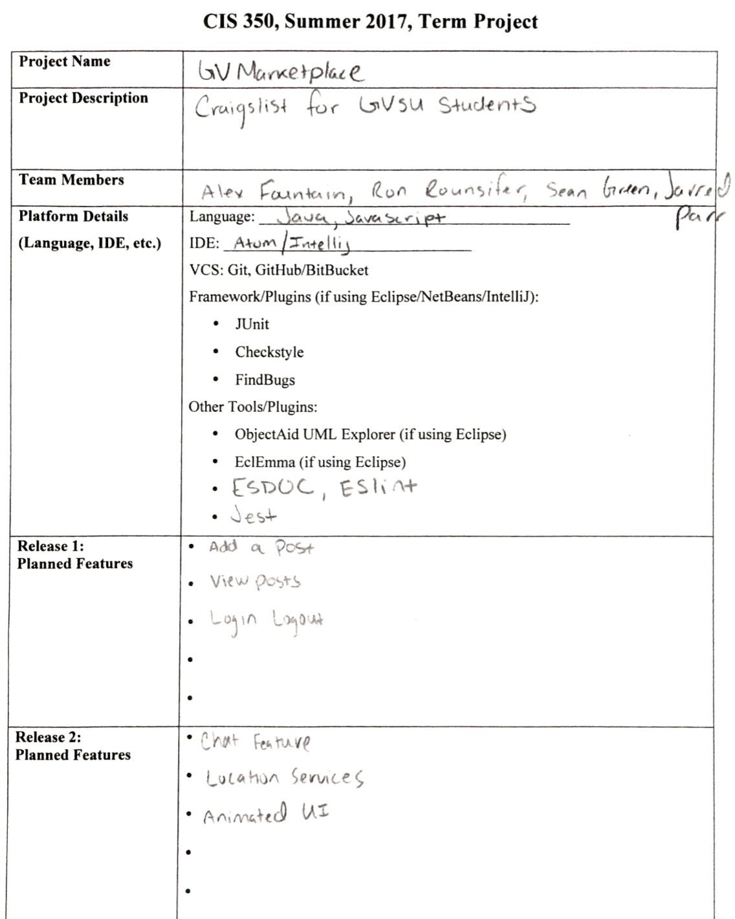

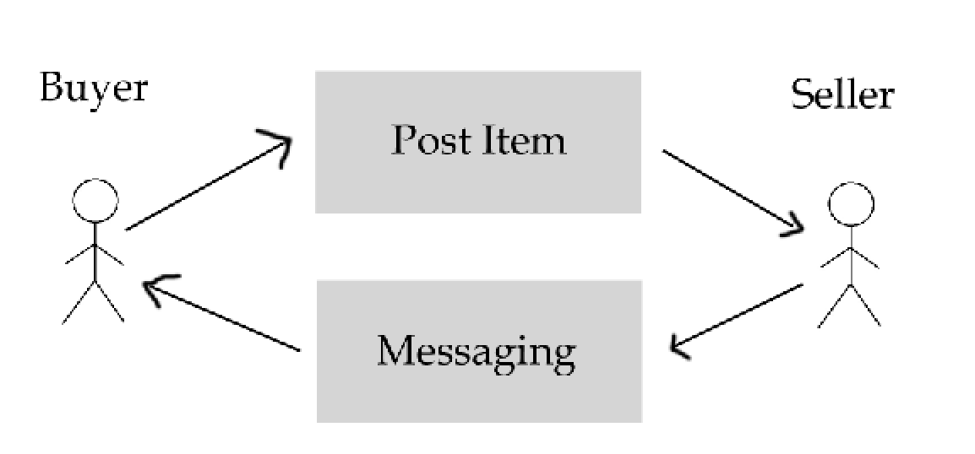**Use Case Diagram**

**Use Case Post**

|  |  |
| --- | --- |
| **Name** | Create Post |
| **ID** | UC1 |
| **Brief Description** | A post is created by a seller to sell an item or good and a buyer interacts with that post. |
| **Actors (primary and supporting/secondary)** | Seller – Primary  Buyer – Secondary |
| **Triggers** | User logs in |
| **Preconditions** | A user must have an account or create an account |
| **Primary Flow** | 1. User provides correct login data  2. Database approves login  3. User selects “Sell” page  4. User enters data about the item they want to sell  5. User selects “Create Post”  6. Database responds by adding the post to items for sale  7. User continues creating posts or looking for items to buy |
| **Secondary Flow** | 2a.1 User provides incorrect login data  3a.1 User gets five login attempts before being prompted to reset password  4a.1 User successfully logs in and continues with step 2  2b.1 Database does not respond  3b.1 Application tries to reconnect  4b.1 Database successfully reconnects and continues with step 2  2b.1 Database does not respond  3b.1 Application tries to reconnect  4b.1 Database fails to reconnect  5b.1 Error is shown to user saying that the application is currently down  6c.1 Database does not respond  7c.1 Application tries to reconnect  8c.1 Database fails to reconnect  9c.1 Error is shown to user saying that the application is currently down  6d.1 Database does not respond  7d.1 Application tries to reconnect  8d.1 Database successfully reconnects and continues with step 7  . |
| **Minimal Guarantees** | If all fails the application will display an error stating that the application is currently unavailable. On close of this error the application will close. |
| **Success Guarantees** | A post is created and other users can interact with the post. |

**Use Case Buy**

|  |  |
| --- | --- |
| **Name** | Buy Post |
| **ID** | UC2 |
| **Brief Description** | A post is created by a seller to sell an item or good and a buyer interacts with that post. |
| **Actors (primary and supporting/secondary)** | Seller – Secondary  Buyer – Primary |
| **Triggers** | User logs in |
| **Preconditions** | A user must have an account or create an account |
| **Primary Flow** | 1. User provides correct login data  2. Database approves login  3. User selects “Buy” page  4. User finds a post that they want to buy  5. User selects “Message seller”  6. Application creates message between buyer and seller  7. Buyer messages seller about an offer for the item and where to meet |
| **Secondary Flow** | 2a.1 User provides incorrect login data  3a.1 User gets five login attempts before being prompted to reset password  4a.1 User successfully logs in and continues with step 2  2b.1 Database does not respond  3b.1 Application tries to reconnect  4b.1 Database successfully reconnects and continues with step 2  2b.1 Database does not respond  3b.1 Application tries to reconnect  4b.1 Database fails to reconnect  5b.1 Error is shown to user saying that the application is currently down  6c.1 Database does not respond  7c.1 Application tries to reconnect  8c.1 Database fails to reconnect  9c.1 Error is shown to user saying that the application is currently down  6d.1 Database does not respond  7d.1 Application tries to reconnect  8d.1 Database successfully reconnects and continues with step 7  . |
| **Minimal Guarantees** | If all fails the application will display an error stating that the application is currently unavailable. On close of this error the application will close. |
| **Success Guarantees** | A message is sent to another user about the item they have for sale. |

Check Style Report (React Native)

[4m/Users/Jarred/Desktop/Programming/CIS-350/GvMarketplace/gvmarket/src/actions/index.js[24m

[2m57:22[22m [31merror[39m There should be no spaces inside this paren [2mspace-in-parens[22m

[2m57:40[22m [31merror[39m There should be no spaces inside this paren [2mspace-in-parens[22m

[2m64:9[22m [33mwarning[39m Unexpected console statement [2mno-console[22m

[2m68:44[22m [31merror[39m Missing semicolon [2msemi[22m

[2m78:37[22m [31merror[39m Missing trailing comma [2mcomma-dangle[22m

[2m79:4[22m [31merror[39m Missing semicolon [2msemi[22m

[4m/Users/Jarred/Desktop/Programming/CIS-350/GvMarketplace/gvmarket/src/app.js[24m

[2m2:10[22m [31merror[39m 'Provider' is defined but never used [2mno-unused-vars[22m

[2m3:10[22m [31merror[39m 'createStore' is defined but never used [2mno-unused-vars[22m

[2m3:23[22m [31merror[39m 'applyMiddleware' is defined but never used [2mno-unused-vars[22m

[2m4:8[22m [31merror[39m 'ReduxThunk' is defined but never used [2mno-unused-vars[22m

[2m9:8[22m [31merror[39m 'reducers' is defined but never used [2mno-unused-vars[22m

[2m16:29[22m [31merror[39m Block must not be padded by blank lines [2mpadded-blocks[22m

[2m37:12[22m [31merror[39m Block must not be padded by blank lines [2mpadded-blocks[22m

[4m/Users/Jarred/Desktop/Programming/CIS-350/GvMarketplace/gvmarket/src/components/browse.js[24m

[2m52:22[22m [31merror[39m Parsing error: Unexpected token =

[4m/Users/Jarred/Desktop/Programming/CIS-350/GvMarketplace/gvmarket/src/components/common/button.js[24m

[2m8:38[22m [31merror[39m 'styles' was used before it was defined [2mno-use-before-define[22m

[2m26:22[22m [31merror[39m Missing trailing comma [2mcomma-dangle[22m

[2m36:19[22m [31merror[39m Missing trailing comma [2mcomma-dangle[22m

[2m37:4[22m [31merror[39m Missing trailing comma [2mcomma-dangle[22m

[4m/Users/Jarred/Desktop/Programming/CIS-350/GvMarketplace/gvmarket/src/components/common/buttonCard.js[24m

[2m9:18[22m [31merror[39m 'styles' was used before it was defined [2mno-use-before-define[22m

[2m25:25[22m [31merror[39m Missing trailing comma [2mcomma-dangle[22m

[2m26:4[22m [31merror[39m Missing trailing comma [2mcomma-dangle[22m

[4m/Users/Jarred/Desktop/Programming/CIS-350/GvMarketplace/gvmarket/src/components/common/card.js[24m

[2m9:18[22m [31merror[39m 'styles' was used before it was defined [2mno-use-before-define[22m

[2m28:18[22m [31merror[39m Missing trailing comma [2mcomma-dangle[22m

[4m/Users/Jarred/Desktop/Programming/CIS-350/GvMarketplace/gvmarket/src/components/common/cardSection.js[24m

[2m9:18[22m [31merror[39m 'styles' was used before it was defined [2mno-use-before-define[22m

[2m23:25[22m [31merror[39m Missing trailing comma [2mcomma-dangle[22m

[2m24:4[22m [31merror[39m Missing trailing comma [2mcomma-dangle[22m

[4m/Users/Jarred/Desktop/Programming/CIS-350/GvMarketplace/gvmarket/src/components/common/deleteAccountButton.js[24m

[2m8:38[22m [31merror[39m 'styles' was used before it was defined [2mno-use-before-define[22m

[2m26:22[22m [31merror[39m Missing trailing comma [2mcomma-dangle[22m

[2m33:19[22m [31merror[39m Missing trailing comma [2mcomma-dangle[22m

[2m34:4[22m [31merror[39m Missing trailing comma [2mcomma-dangle[22m

[4m/Users/Jarred/Desktop/Programming/CIS-350/GvMarketplace/gvmarket/src/components/common/header.js[24m

[2m1:15[22m [31merror[39m A space is required after '{' [2mobject-curly-spacing[22m

[2m1:25[22m [31merror[39m A space is required before '}' [2mobject-curly-spacing[22m

[2m1:28[22m [31merror[39m Multiple spaces found before 'from' [2mno-multi-spaces[22m

[2m2:34[22m [31merror[39m 'TouchableOpacity' is defined but never used [2mno-unused-vars[22m

[2m3:10[22m [31merror[39m 'Avatar' is defined but never used [2mno-unused-vars[22m

[2m3:18[22m [31merror[39m 'Icon' is defined but never used [2mno-unused-vars[22m

[2m4:8[22m [31merror[39m A space is required after '{' [2mobject-curly-spacing[22m

[2m4:16[22m [31merror[39m A space is required before '}' [2mobject-curly-spacing[22m

[2m13:20[22m [31merror[39m 'styles' was used before it was defined [2mno-use-before-define[22m

[2m14:22[22m [31merror[39m 'styles' was used before it was defined [2mno-use-before-define[22m

[2m15:24[22m [31merror[39m 'styles' was used before it was defined [2mno-use-before-define[22m

[2m40:26[22m [31merror[39m 'state' is defined but never used [2mno-unused-vars[22m

[2m45:28[22m [31merror[39m Unexpected parentheses around single function argument having a body with no curly braces [2marrow-parens[22m

[2m48:4[22m [31merror[39m Missing trailing comma [2mcomma-dangle[22m

[2m54:21[22m [31merror[39m Unexpected space between function name and paren [2mno-spaced-func[22m

[2m54:21[22m [31merror[39m Unexpected space between function name and paren [2mfunc-call-spacing[22m

[2m55:1[22m [31merror[39m Unexpected newline between function and ( of function call [2mno-unexpected-multiline[22m

[4m/Users/Jarred/Desktop/Programming/CIS-350/GvMarketplace/gvmarket/src/components/common/input.js[24m

[2m13:54[22m [31merror[39m 'styles' was used before it was defined [2mno-use-before-define[22m

[2m38:12[22m [31merror[39m Missing trailing comma [2mcomma-dangle[22m

[2m43:12[22m [31merror[39m Missing trailing comma [2mcomma-dangle[22m

[2m49:25[22m [31merror[39m Missing trailing comma [2mcomma-dangle[22m

[2m50:4[22m [31merror[39m Missing trailing comma [2mcomma-dangle[22m

[4m/Users/Jarred/Desktop/Programming/CIS-350/GvMarketplace/gvmarket/src/components/common/loginButton.js[24m

[2m8:38[22m [31merror[39m 'styles' was used before it was defined [2mno-use-before-define[22m

[2m26:22[22m [31merror[39m Missing trailing comma [2mcomma-dangle[22m

[2m33:19[22m [31merror[39m Missing trailing comma [2mcomma-dangle[22m

[2m34:4[22m [31merror[39m Missing trailing comma [2mcomma-dangle[22m

[4m/Users/Jarred/Desktop/Programming/CIS-350/GvMarketplace/gvmarket/src/components/common/loginCard.js[24m

[2m9:18[22m [31merror[39m 'styles' was used before it was defined [2mno-use-before-define[22m

[2m20:18[22m [31merror[39m Missing trailing comma [2mcomma-dangle[22m

[4m/Users/Jarred/Desktop/Programming/CIS-350/GvMarketplace/gvmarket/src/components/common/loginInput.js[24m

[2m2:27[22m [31merror[39m 'Text' is defined but never used [2mno-unused-vars[22m

[2m13:23[22m [31merror[39m 'labelStyle' is assigned a value but never used [2mno-unused-vars[22m

[2m13:54[22m [31merror[39m 'styles' was used before it was defined [2mno-use-before-define[22m

[2m44:4[22m [31merror[39m Missing trailing comma [2mcomma-dangle[22m

[4m/Users/Jarred/Desktop/Programming/CIS-350/GvMarketplace/gvmarket/src/components/common/loginTitle.js[24m

[2m1:15[22m [31merror[39m A space is required after '{' [2mobject-curly-spacing[22m

[2m1:25[22m [31merror[39m A space is required before '}' [2mobject-curly-spacing[22m

[2m1:28[22m [31merror[39m Multiple spaces found before 'from' [2mno-multi-spaces[22m

[2m2:34[22m [31merror[39m 'TouchableOpacity' is defined but never used [2mno-unused-vars[22m

[2m3:10[22m [31merror[39m 'Avatar' is defined but never used [2mno-unused-vars[22m

[2m3:18[22m [31merror[39m 'Icon' is defined but never used [2mno-unused-vars[22m

[2m4:8[22m [31merror[39m A space is required after '{' [2mobject-curly-spacing[22m

[2m4:16[22m [31merror[39m A space is required before '}' [2mobject-curly-spacing[22m

[2m13:20[22m [31merror[39m 'styles' was used before it was defined [2mno-use-before-define[22m

[2m14:22[22m [31merror[39m 'styles' was used before it was defined [2mno-use-before-define[22m

[2m15:24[22m [31merror[39m 'styles' was used before it was defined [2mno-use-before-define[22m

[2m40:26[22m [31merror[39m 'state' is defined but never used [2mno-unused-vars[22m

[2m45:28[22m [31merror[39m Unexpected parentheses around single function argument having a body with no curly braces [2marrow-parens[22m

[2m48:4[22m [31merror[39m Missing trailing comma [2mcomma-dangle[22m

[2m54:21[22m [31merror[39m Unexpected space between function name and paren [2mno-spaced-func[22m

[2m54:21[22m [31merror[39m Unexpected space between function name and paren [2mfunc-call-spacing[22m

[2m55:1[22m [31merror[39m Unexpected newline between function and ( of function call [2mno-unexpected-multiline[22m

[4m/Users/Jarred/Desktop/Programming/CIS-350/GvMarketplace/gvmarket/src/components/common/pageView.js[24m

[2m10:19[22m [31merror[39m 'styles' was used before it was defined [2mno-use-before-define[22m

[2m18:12[22m [31merror[39m Missing trailing comma [2mcomma-dangle[22m

[4m/Users/Jarred/Desktop/Programming/CIS-350/GvMarketplace/gvmarket/src/components/common/post.js[24m

[2m3:10[22m [31merror[39m 'Button' is defined but never used [2mno-unused-vars[22m

[2m13:24[22m [31merror[39m 'styles' was used before it was defined [2mno-use-before-define[22m

[2m16:24[22m [31merror[39m 'styles' was used before it was defined [2mno-use-before-define[22m

[2m19:24[22m [31merror[39m 'styles' was used before it was defined [2mno-use-before-define[22m

[4m/Users/Jarred/Desktop/Programming/CIS-350/GvMarketplace/gvmarket/src/components/common/searchBar.js[24m

[2m1:17[22m [31merror[39m 'Component' is defined but never used [2mno-unused-vars[22m

[2m2:27[22m [31merror[39m 'Text' is defined but never used [2mno-unused-vars[22m

[2m14:18[22m [31merror[39m 'styles' was used before it was defined [2mno-use-before-define[22m

[2m15:20[22m [31merror[39m 'styles' was used before it was defined [2mno-use-before-define[22m

[2m19:16[22m [31merror[39m 'styles' was used before it was defined [2mno-use-before-define[22m

[2m46:4[22m [31merror[39m Missing trailing comma [2mcomma-dangle[22m

[2m47:2[22m [31merror[39m Missing semicolon [2msemi[22m

[4m/Users/Jarred/Desktop/Programming/CIS-350/GvMarketplace/gvmarket/src/components/common/smallCard.js[24m

[2m10:18[22m [31merror[39m 'styles' was used before it was defined [2mno-use-before-define[22m

[4m/Users/Jarred/Desktop/Programming/CIS-350/GvMarketplace/gvmarket/src/components/common/smallHeader.js[24m

[2m9:36[22m [31merror[39m 'styles' was used before it was defined [2mno-use-before-define[22m

[2m14:1[22m [31merror[39m Expected indentation of 2 spaces but found 0 [2mindent[22m

[2m21:25[22m [31merror[39m Missing trailing comma [2mcomma-dangle[22m

[2m27:4[22m [31merror[39m Missing trailing comma [2mcomma-dangle[22m

[4m/Users/Jarred/Desktop/Programming/CIS-350/GvMarketplace/gvmarket/src/components/common/spinner.js[24m

[2m10:18[22m [31merror[39m 'styles' was used before it was defined [2mno-use-before-define[22m

[2m13:4[22m [31merror[39m Missing semicolon [2msemi[22m

[2m20:25[22m [31merror[39m Missing trailing comma [2mcomma-dangle[22m

[2m21:4[22m [31merror[39m Missing trailing comma [2mcomma-dangle[22m

[4m/Users/Jarred/Desktop/Programming/CIS-350/GvMarketplace/gvmarket/src/components/inbox.js[24m

[2m11:31[22m [31merror[39m Block must not be padded by blank lines [2mpadded-blocks[22m

[2m19:22[22m [31merror[39m 'styles' was used before it was defined [2mno-use-before-define[22m

[2m20:1[22m [31merror[39m Line 20 exceeds the maximum line length of 100 [2mmax-len[22m

[2m20:24[22m [31merror[39m 'styles' was used before it was defined [2mno-use-before-define[22m

[2m20:75[22m [31merror[39m Unexpected usage of singlequote [2mjsx-quotes[22m

[2m20:95[22m [31merror[39m Unexpected usage of singlequote [2mjsx-quotes[22m

[2m22:1[22m [31merror[39m Expected indentation of 10 spaces but found 8 [2mindent[22m

[2m22:1[22m [31merror[39m Line 22 exceeds the maximum line length of 100 [2mmax-len[22m

[2m22:9[22m [31merror[39m Expected indentation of 10 space characters but found 8 [2mreact/jsx-indent[22m

[2m22:22[22m [31merror[39m 'styles' was used before it was defined [2mno-use-before-define[22m

[2m22:74[22m [31merror[39m Unexpected usage of singlequote [2mjsx-quotes[22m

[2m22:96[22m [31merror[39m Unexpected usage of singlequote [2mjsx-quotes[22m

[2m26:24[22m [31merror[39m 'styles' was used before it was defined [2mno-use-before-define[22m

[2m27:24[22m [31merror[39m Unexpected usage of singlequote [2mjsx-quotes[22m

[2m27:40[22m [31merror[39m Unexpected usage of singlequote [2mjsx-quotes[22m

[2m56:2[22m [31merror[39m Missing semicolon [2msemi[22m

[4m/Users/Jarred/Desktop/Programming/CIS-350/GvMarketplace/gvmarket/src/components/login.js[24m

[2m5:10[22m [31merror[39m 'Header' is defined but never used [2mno-unused-vars[22m

[2m5:42[22m [31merror[39m 'Card' is defined but never used [2mno-unused-vars[22m

[2m5:48[22m [31merror[39m 'CardSection' is defined but never used [2mno-unused-vars[22m

[2m5:83[22m [31merror[39m 'LoginCard' is defined but never used [2mno-unused-vars[22m

[2m5:106[22m [31merror[39m 'LoginInput' is defined but never used [2mno-unused-vars[22m

[2m11:31[22m [31merror[39m Block must not be padded by blank lines [2mpadded-blocks[22m

[2m34:22[22m [31merror[39m A space is required after '{' [2mobject-curly-spacing[22m

[2m40:29[22m [31merror[39m Unexpected parentheses around single function argument having a body with no curly braces [2marrow-parens[22m

[2m50:29[22m [31merror[39m Unexpected parentheses around single function argument having a body with no curly braces [2marrow-parens[22m

[2m59:24[22m [31merror[39m 'styles' was used before it was defined [2mno-use-before-define[22m

[2m62:24[22m [31merror[39m 'styles' was used before it was defined [2mno-use-before-define[22m

[2m84:28[22m [31merror[39m Unexpected parentheses around single function argument having a body with no curly braces [2marrow-parens[22m

[2m93:4[22m [31merror[39m Missing trailing comma [2mcomma-dangle[22m

[2m100:17[22m [31merror[39m Missing trailing comma [2mcomma-dangle[22m

[4m/Users/Jarred/Desktop/Programming/CIS-350/GvMarketplace/gvmarket/src/components/popups/newPostDialogue.js[24m

[2m9:20[22m [31merror[39m 'Card' is defined but never used [2mno-unused-vars[22m

[2m9:26[22m [31merror[39m 'CardSection' is defined but never used [2mno-unused-vars[22m

[2m9:66[22m [31merror[39m 'LoginCard' is defined but never used [2mno-unused-vars[22m

[2m15:50[22m [31merror[39m Block must not be padded by blank lines [2mpadded-blocks[22m

[2m71:26[22m [31merror[39m Strings must use singlequote [2mquotes[22m

[2m76:26[22m [31merror[39m 'styles' was used before it was defined [2mno-use-before-define[22m

[2m78:24[22m [31merror[39m A space is required after '{' [2mobject-curly-spacing[22m

[2m78:40[22m [31merror[39m A space is required before '}' [2mobject-curly-spacing[22m

[2m79:69[22m [31merror[39m Missing semicolon [2msemi[22m

[2m79:72[22m [31merror[39m The closing bracket must be aligned with the line containing the opening tag (expected column 15 on the next line) [2mreact/jsx-closing-bracket-location[22m

[2m81:25[22m [31merror[39m Strings must use singlequote [2mquotes[22m

[2m87:89[22m [31merror[39m Missing space before value for key 'alignSelf' [2mkey-spacing[22m

[2m94:33[22m [31merror[39m Unexpected parentheses around single function argument having a body with no curly braces [2marrow-parens[22m

[2m103:33[22m [31merror[39m Unexpected parentheses around single function argument having a body with no curly braces [2marrow-parens[22m

[2m112:33[22m [31merror[39m Unexpected parentheses around single function argument having a body with no curly braces [2marrow-parens[22m

[2m131:52[22m [31merror[39m The closing bracket must be aligned with the line containing the opening tag (expected column 17 on the next line) [2mreact/jsx-closing-bracket-location[22m

[2m140:62[22m [31merror[39m The closing bracket must be aligned with the line containing the opening tag (expected column 9 on the next line) [2mreact/jsx-closing-bracket-location[22m

[2m160:28[22m [31merror[39m Missing trailing comma [2mcomma-dangle[22m

[2m166:4[22m [31merror[39m Missing trailing comma [2mcomma-dangle[22m

[2m167:2[22m [31merror[39m Missing semicolon [2msemi[22m

[2m175:51[22m [31merror[39m Missing trailing comma [2mcomma-dangle[22m

[2m183:28[22m [31merror[39m Unexpected parentheses around single function argument having a body with no curly braces [2marrow-parens[22m

[2m186:4[22m [31merror[39m Missing trailing comma [2mcomma-dangle[22m

[4m/Users/Jarred/Desktop/Programming/CIS-350/GvMarketplace/gvmarket/src/components/settings.js[24m

[2m2:16[22m [31merror[39m 'ScrollView' is defined but never used [2mno-unused-vars[22m

[2m2:28[22m [31merror[39m 'FlatList' is defined but never used [2mno-unused-vars[22m

[2m2:38[22m [31merror[39m 'Text' is defined but never used [2mno-unused-vars[22m

[2m17:22[22m [31merror[39m 'styles' was used before it was defined [2mno-use-before-define[22m

[2m62:18[22m [31merror[39m Missing trailing comma [2mcomma-dangle[22m

[2m66:4[22m [31merror[39m Missing trailing comma [2mcomma-dangle[22m

[2m67:2[22m [31merror[39m Missing semicolon [2msemi[22m

[4m/Users/Jarred/Desktop/Programming/CIS-350/GvMarketplace/gvmarket/src/router.js[24m

[2m6:20[22m [31merror[39m Parse errors in imported module './components/browse': Unexpected token = (52:22) [2mimport/no-named-as-default[22m

[2m6:20[22m [31merror[39m Parse errors in imported module './components/browse': Unexpected token = (52:22) [2mimport/no-named-as-default-member[22m

[2m26:31[22m [31merror[39m The closing bracket must be aligned with the line containing the opening tag (expected column 11 on the next line) [2mreact/jsx-closing-bracket-location[22m

[2m28:8[22m [31merror[39m Missing trailing comma [2mcomma-dangle[22m

[2m39:31[22m [31merror[39m The closing bracket must be aligned with the line containing the opening tag (expected column 11 on the next line) [2mreact/jsx-closing-bracket-location[22m

[2m40:10[22m [31merror[39m Missing trailing comma [2mcomma-dangle[22m

[2m41:8[22m [31merror[39m Missing trailing comma [2mcomma-dangle[22m

[2m52:31[22m [31merror[39m The closing bracket must be aligned with the line containing the opening tag (expected column 11 on the next line) [2mreact/jsx-closing-bracket-location[22m

[2m53:10[22m [31merror[39m Missing trailing comma [2mcomma-dangle[22m

[2m54:8[22m [31merror[39m Missing trailing comma [2mcomma-dangle[22m

[2m66:4[22m [31merror[39m Missing trailing comma [2mcomma-dangle[22m

[31m[1m✖ 172 problems (171 errors, 1 warning)[22m[39m

[31m[1m[22m[39m[31m[1m 100 errors, 0 warnings potentially fixable with the `--fix` option.[22m[39m

[31m[1m[22m[39m

Screenshots

Desktop: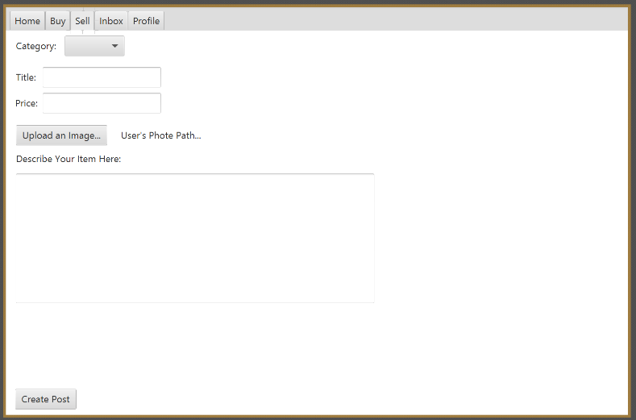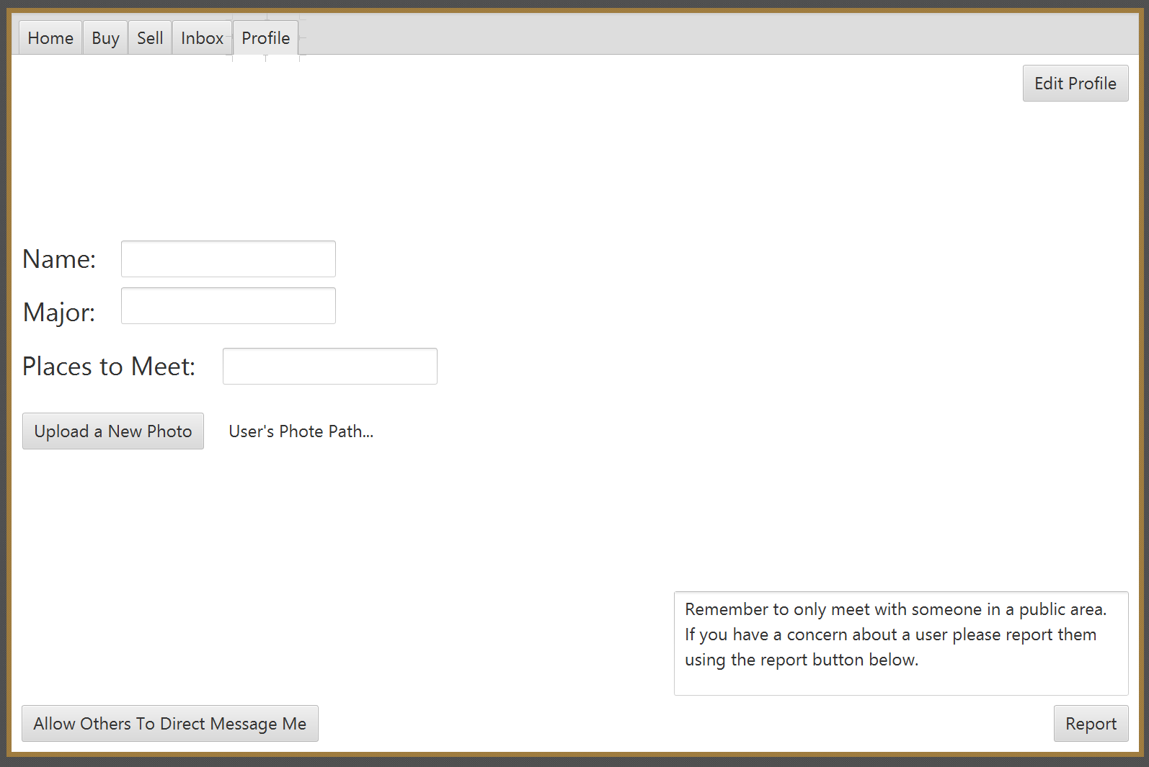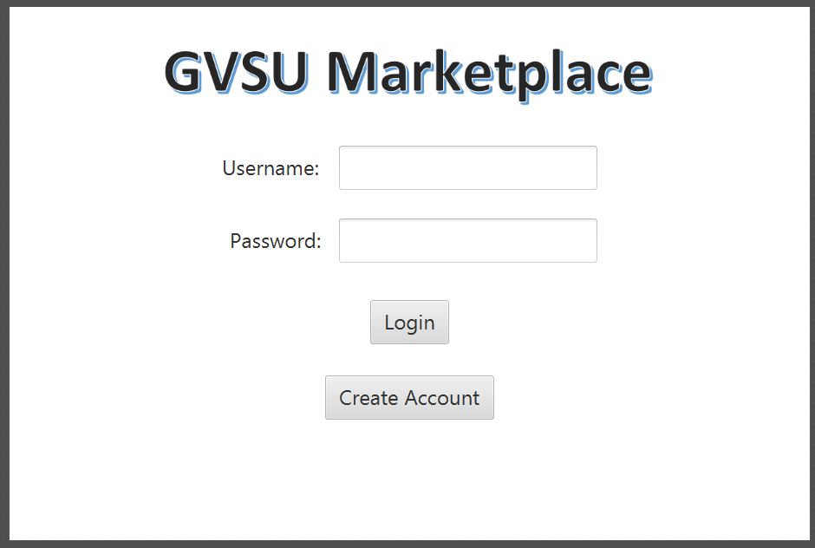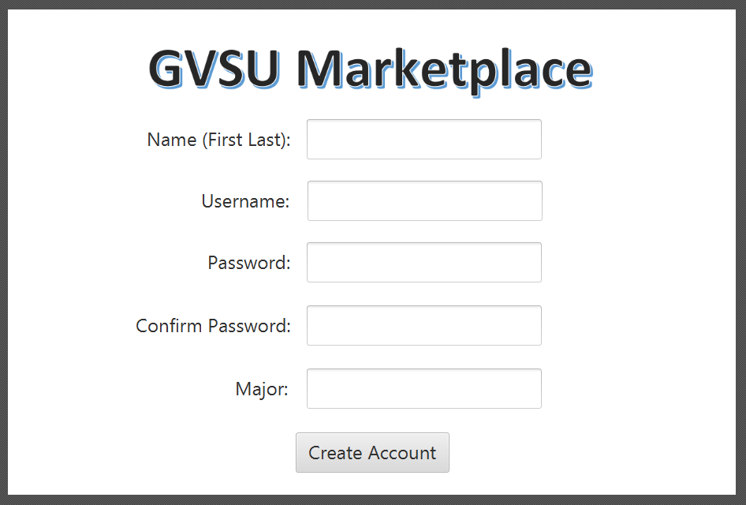

Mobile App:

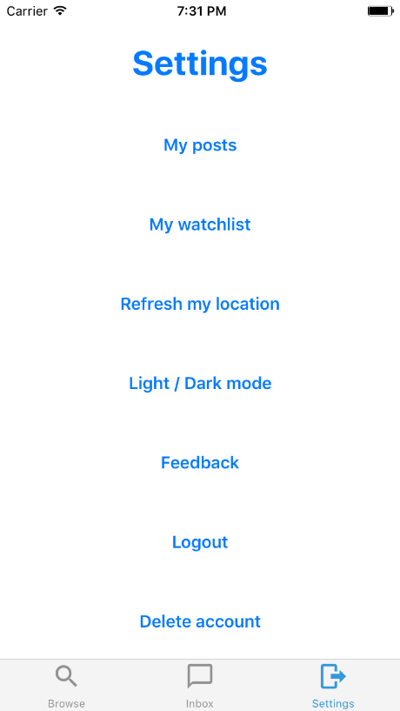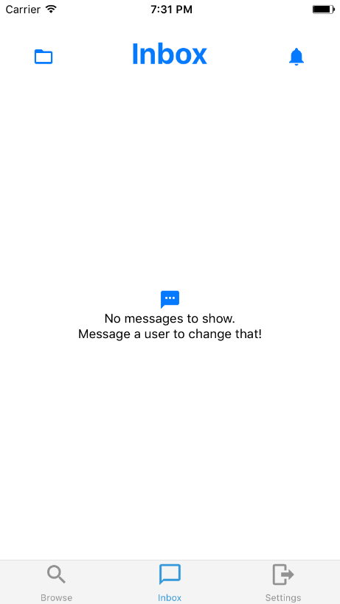

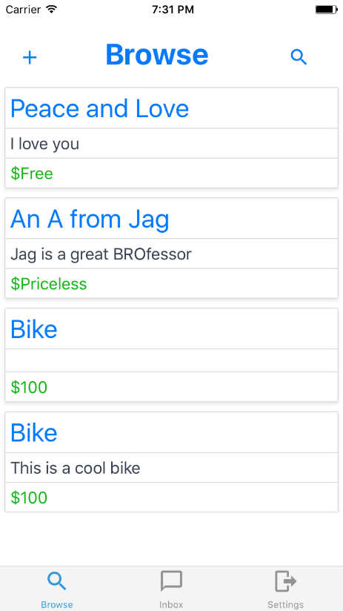

Roles

Jarred:

I was mostly in charge of handling the back end of the application. I set up the database connections as well as handled the login capabilities of the application.

Ron:

I took care of the front end for the application on Mobile. I picked the color scheme, and handled making the app look pretty and building reusable components to make the app more modular.

Alex:

I was in charge of the entire front end of the user interface on the desktop application. I setup the layout of the application, pages, and page layout. I also worked on most of the documentation for the desktop application.

Sean:

I was in charge of error checking and linking the pieces in the user interface to the java docs. I also created the java doc and code coverage documentation.

Reflections

Jarred:

My role was to design the back end of both applications. I was successful by first build and got the application to pull and post to the database as well as built the login functionality on the app for the first release. I’d like to set up a docker container to house the app for the net build so the team can have a consistent version of dependencies across releases. Overall this was a great first start, the team had some inconsistencies in the beginning but it looks like we’re figuring things out.

Ron:

My contribution to the project mainly consisted of documentation and front end design for the mobile application. Everything promised for the first build was incorporated while presenting the user with a simplistic design scheme in order to provide the user with an easy-to-use, no instructions-needed-application. I am going to continue modifying the design of the mobile application until I deem acceptable for release two, while incorporating the functionality of the design features. Also, I wish to see the mobile and desktop applications to have a similar look and feel to their UI’s, but that task may be too optimistic for our second release. All-in-all, it was a good first step for our developing applications and I see our work becoming more effective and efficient for this upcoming release.

Alex:

My role in the project was to develop the user interface of the desktop application. The plan was to then develop the majority of the backend of the application for the second release but looking back it would have been better to have also tried to include the basic backend stuff so that there was more of a deliverable. I am happy with how the user interface looks and I feel it will be very simple for the user to catch on to how to use it. Jarred and Ron did a fantastic job with the mobile app and I look forward to working with them for the second release to bring the applications even closer together in look and feel. I think that the group is beginning to hit our groove of accomplishing our goals and the second half of the project should go very smoothly.

Sean:

My job was to work with Alex on the desktop application. At the beginning of the semester I shied away from contributions due to a lack of understanding the material. With the help of YouTube tutorials, I have become an active member of the development team. I’ve made several additions to the layout of the interface as well as minor bug fixes and the entire controller set up for user interaction. Jarred and Ron got the android app up and running in record time and Alex has done a great job with the initial interface for GV Marketplace. The plan was to have a basic GUI that outlined the goals for a finished GV Marketplace Application in release one and a full feature application with a working database for release two. I am glad to see improved group communication as the semester progresses. I believe we’ll be ready for release two in no time.